

**King County**

**Renovation**

**Opportunities**



**Summary**



**XYZ Renovations is a construction**

**company in King County that specializes**

**in home renovation. They also purchase**

**homes to buy, renovate and then sell for**

**profit.**

**We will analyse**

**the King County property**

**data to provide insights how they can**

**improve their business and marketing.**



**Agenda**

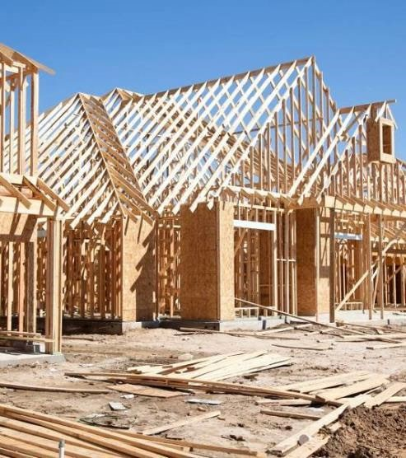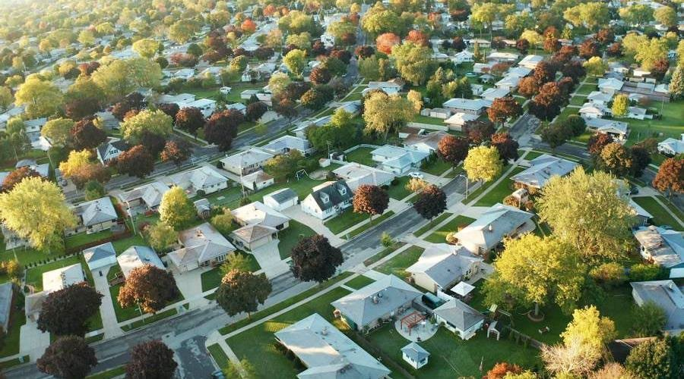

•

**Business objectives**

•

**Data**

•

**Methods**

•

**Results**

•

**Recommendations**

•

**Next Steps**

# Business Objectives

XYZ Renovations has been successful in a limited market and looks to increase its business throughout the king county area.

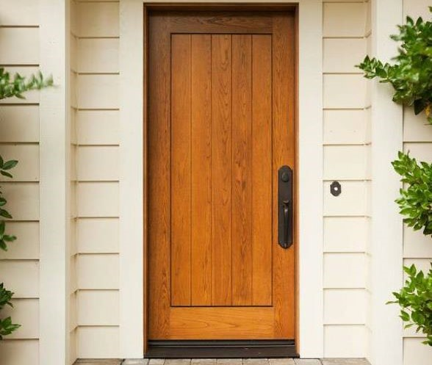With the provided king county data, we expect to be able to provide information to assist in generating strategies to achieve this objective. This will include:

1. How do renovations effect house prices and property value?
2. If renovating, what criteria should be used in determining desired outcomes?
3. Where should XYZ Renovations concentrate is marketing efforts to find clients and conduct searches for suitable properties to buy to renovate and sell?

# Data

|  |  |  |  |
| --- | --- | --- | --- |
| **2015.**  **This data has information on property features such as how many bedrooms and bathrooms, the properties age, zipcode,** | **The data is robust, with information on more than 21,000 properties.** | **The data also contained**  **definitions on the various features that have been listed.** | **We were able to retain much of the data but removed**  **outliers to keep the data consistent.** |

**King County keeps property data on properties sold through out the area and we have been provided the data on these properties that were sold during 2014 and**

**living areas and the properties near it but it also other features such as if the property has been renovated, and if so, when, if it is waterfront.**

**We were forced to drop some features either due to non relevance or lack of clarity around the definition of the information.**

# Methods

**Considered was the provided data in its entirety as well as splitting the data into renovated properties and non renovated properties to consider the differences.**

**This analysis largely looks at the cause and effect of median house prices in each zipcode through out the King County area. Before looking to analyse the data to provide insights and recommendations for the business objectives, all features were thoroughly investigated for relevance to prices and relationships with other features.**

**Some features were dropped due to a lack of relevance and/or a lack of clarity on how the information was gathered and/or its meaning.**

# Results

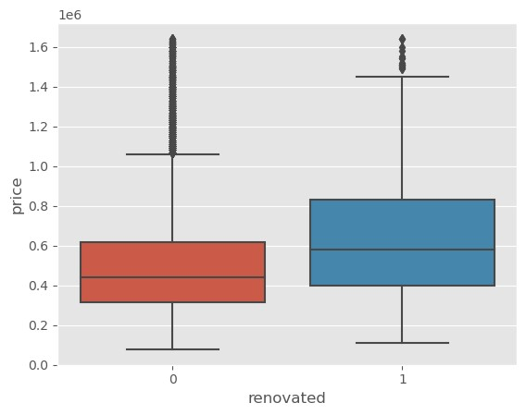**Effects on home value due to renovations**

**The median price for renovated properties is significantly higher than the non renovated properties. This price is in excess of $80,000, or 15.6%, when mean prices per zipcode were compared.**

**Both condition and grade are positively affected by renovation, noting that recently renovated does not have a condition rating below 3.**

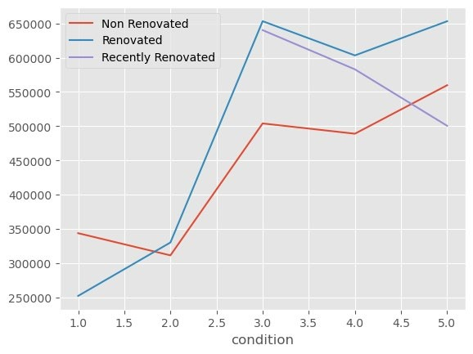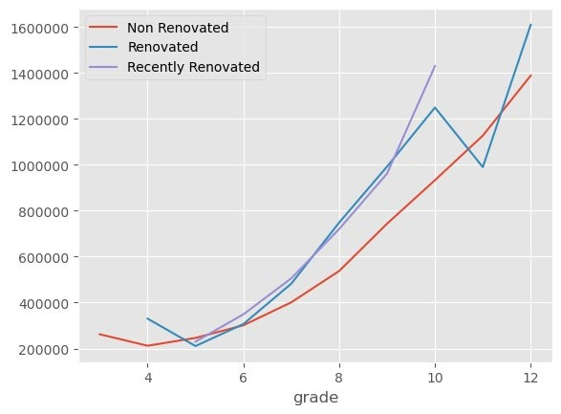

**This would indicate that homes who have a condition lower than 3 and/or a grade lower than 6 can significantly increase the value of their property with renovations**

# Results

**Desired renovation outcomes**

20

XX

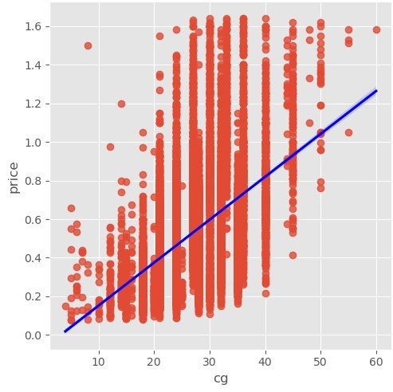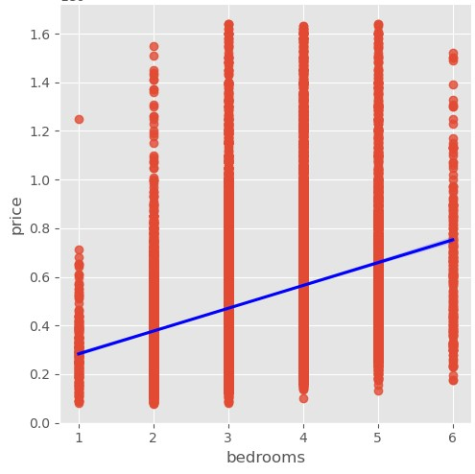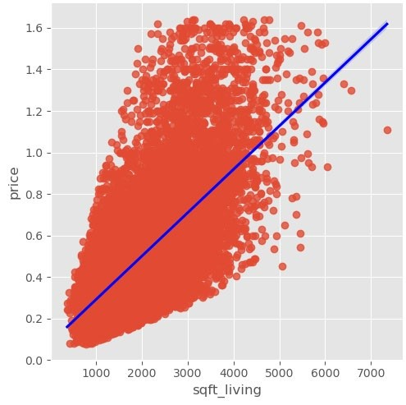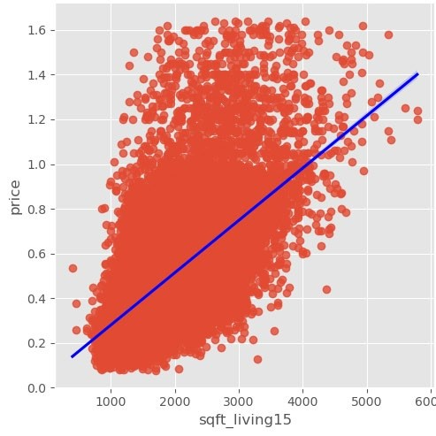

**After creating a model to predict home prices, it was found that the features with the largest effect were;**

1. **The size of the living space and the size of living spaces near by,**
2. **The location, either zipcode or distance to Seattle are good predictors,**
3. **The number of bedrooms,**
4. **The grade of the property,**
5. **The condition of the property (note: cg =condition x grade),**
6. **And if the property has a basement.**

**Given the nature of the business, the features that can be addressed through renovations are the ability to change the size of the living space, the number of bedrooms, the grade and the condition of the property.**

**Any renovations should intend to increase the grade and condition as its first objective. Then review configuration and potential to increase the properties size.**

# Results

**Targeted marketing and property search.**

**Areas with larger concentration of older homes would provide more opportunity for homes in need of**

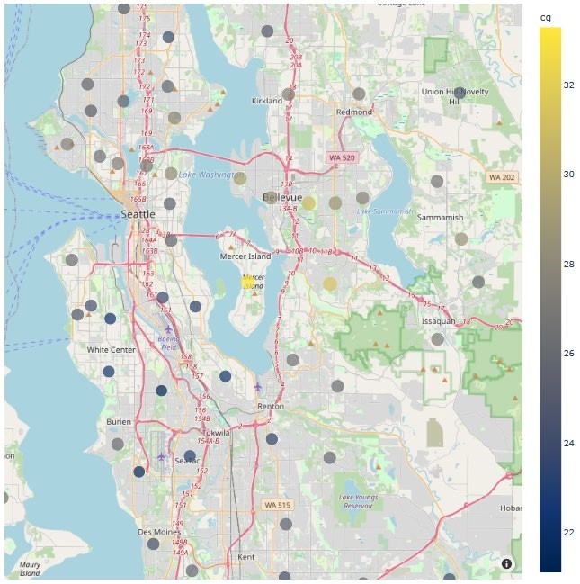

**renovation,**

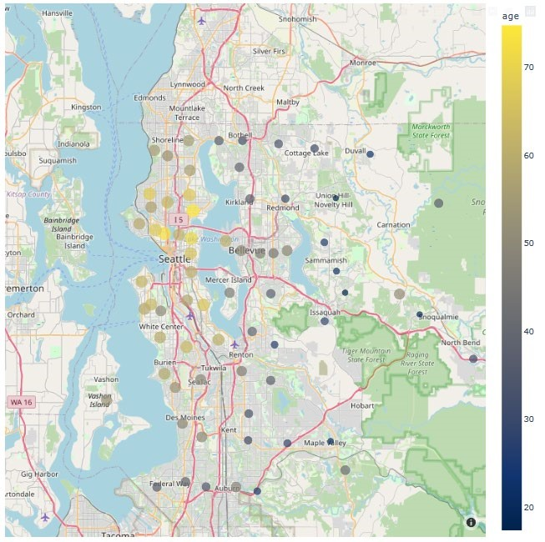

**Areas with larger concentration of low grade and low condition homes (cg=condition * grade),**

# Results

**Where should marketing and property searched be concentrated?**

**Areas already proven to have renovated homes with prices above the area average,**

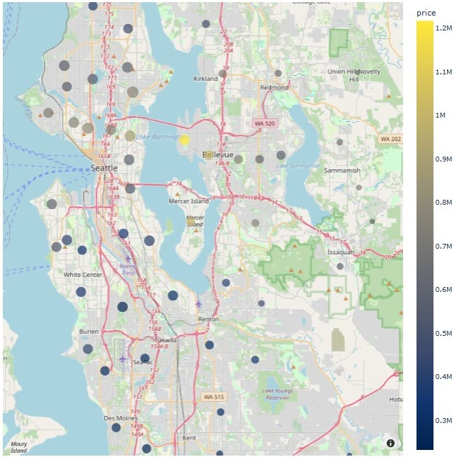

**4. Areas with a higher average price levels will produce greater returns**

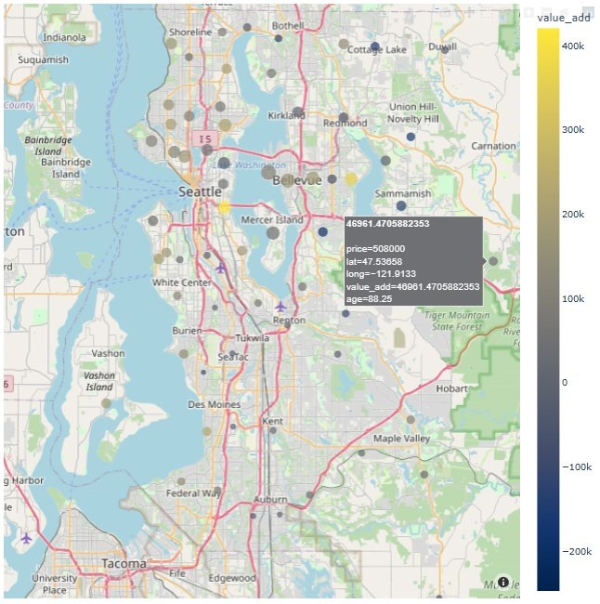

# Results

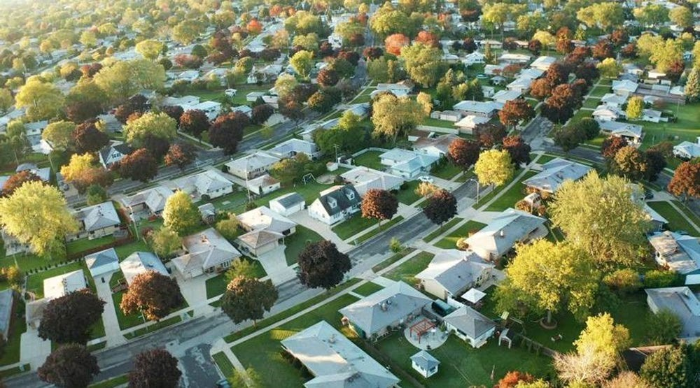**Where should marketing and property searched be concentrated?**

**The zipcodes with the lowest average reported combination of condition and grade and older homes are 98065, 98053, 98038, 98029, 98019, 98075, 98092, 98074, 98045, 98059. This would be a good starting point to focus XYZ Constructions attention.**

|  |
| --- |
| **Conclusion** |

* **The most controllable features of a property are the grade and condition, followed by the square footage of the living space and property amenities, such as the number of bedrooms.**
* **XYZ Renovations would benefit most from marketing its ability to increase property value through increasing its grade and/or condition in most cases but could expand this to include changing layouts and sizes of properties through larger scale renovation.**

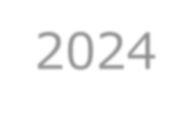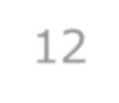

* **XYZ Renovations should target areas, for both marketing and property searches, that have;**
* Higher concentration of older homes.
* Large concentration of documented low condition~grade homes.
* Already proven to have renovated homes with prices above the area average.
* Higher price level that could produce greater returns.

# Next Steps

* **Consult with the data acquisition team to better understand some of the features and information collected, for example the provided definition for bathrooms was number of bathrooms/bedrooms. When expanded out, this number was unrealistic for the number of bathrooms in a home. This feature could have made a strong predictor.**
* 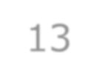**Increase data keeping specifically to renovations and equity/price increases. For example, it would be good to know what type of work was done, the cost, the before and after condition and/or grade scores.**
* **Some clarity around the living space would be of benefit. If we knew if the basement was finished and livable, as well as the area of it, it would provide a better understanding of the value of this being a renovation to increase living space. A better mode of pricing would be a $psqft but due to the provided data, this is not as clear as we would like.**
* **Knowing the property type, apartment/attached home/detached home, would be extremely helpful.**

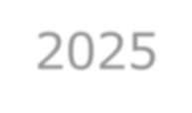2025



**Thank you**

P A U L S T E W A R T | E M A I L : P _ S T E W @ H O T M A I L . C O M

GITHUB:

P A U L S T E W A U

[S](https://github.com/PaulStewAus)

| L I N K E D I N : P A U L S T E W A R T A U S



2024